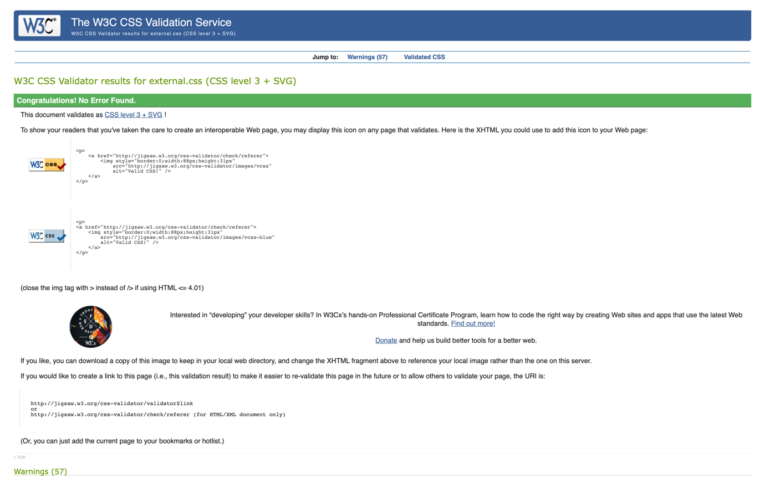

Test CSS general

Test CSS Vinicius page

Performance test

Performance test

Performance test

Performance test

Problem solved

In order to complete this website, all the knowledge acquired in the classroom was applied and adjacent research carried out so that it would be complete in terms of the time proposed and within what was requested and designed by the group. Obviously during development there were some meetings where tempers flared, but we would say that this strengthened the union and brought more understanding and synergy. We can emphasise that the creation of the website was a good review of everything applied in the classes taught and a good exercise with a deadline.